DS 522 Data Acquisition and Analytics
HOS07A-1 –Data Wrangling
10/02/2024 Reviewed by Yogesh Goel
05/13/2025 Reviewed by Naveena Moddu
04/30/2026 Reviewed by Vishal Krishna Kumar

School of Technology & Computing (STC) @ City University of Seattle (CityU)

Take Note Before Starting
- The directory path shown in screenshots may be different from your directory.
- Not every step is explained in the tutorial. If you are not sure what to do:
1. Consult the resources listed below.
2. If you cannot solve the problem after a few tries, email your course TA for help.

Learning Outcomes
- Gain general knowledge regarding the various ways to combine DataFrames.
- Understand the different types of joins.
- Understand how to concatenate Series and DataFrames
- Understand how to reshape data in Pandas.
- Handling multiple levels of indexes in DataFrames.
- Understand data transformation, discretization, and binning.

Resources
- McKinney. (2022). Python for Data Analysis (3rd edition).
- Tutorials Point. (2024). Python Pandas – Merging/Joining. https://www.tutorialspoint.com/python_pandas/python_pandas_merging_joining.htm
- User guide. (n.d.). Pandas. https://pandas.pydata.org/docs/user_guide/index.html

Getting Started
- Open the VS code and within the VS Code, open the DS522 course folder created earlier. On the menu tab, select File, then Open New Folder. Navigate to your work directory or GitHub repository that you have cloned.

Example: C:\ Desktop\DS522 OR C: \Desktop\DS522\github_repository_name
NOTE: If you have cloned a GitHub repository that is provided specifically for this course, navigate to that directory, and skip steps 2 to 4. This will be the folder where you will be storing all your HOS07A work.

- Once in your work directory, go to the menu tab again, select Terminal, select New Terminal to open a Command Line Interface (CLI) like the Command Prompt or PowerShell for Windows OS.

- Inside your “DS522” directory, create a new directory and name it “HOS07A”. Use the following command:
>mkdir HOS07A
- Move to the new directory. Use the following command:
>cd HOS07A
NOTE: This will be the folder where you will be storing all your HOS07A work.

Merge and Join

Often, you will work with data that comes from more than one source. Pandas provides several methods that make working with multiple datasets much easier.

• pandas.merge connects rows in DataFrames based on one or more keys.
• pandas.concat concatenates or “stacks” together objects along an axis.

Merging has several types of joins: one-to-one, many-to-one, and many-to-many. We will start by working with a one-to-one join.

one-to-one Join
In a one-to-one join, only one row from a table may be associated with only one row from
Another table.
- In your HOS07A folder or HOS7A repository, create a New File by clicking File on the top menu bar, then New File, and select the Jupyter Notebook option. Save the file with CTRL + S, rename to wrangling.ipynb

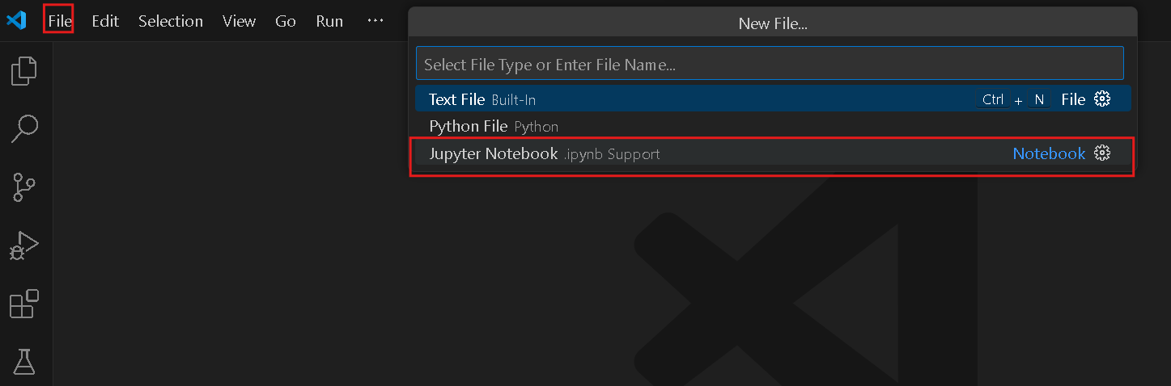
1.I
2. Type the following code in a new code cell and run it to see the output:
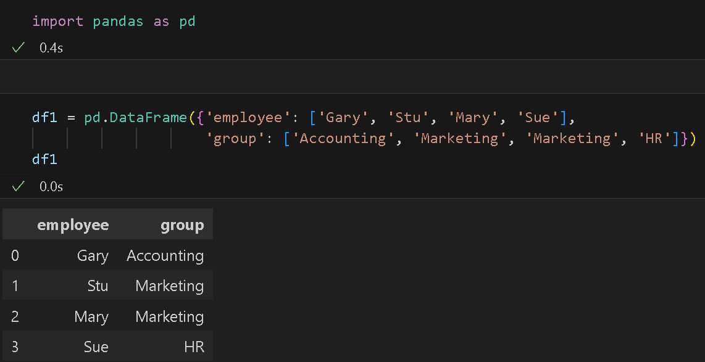
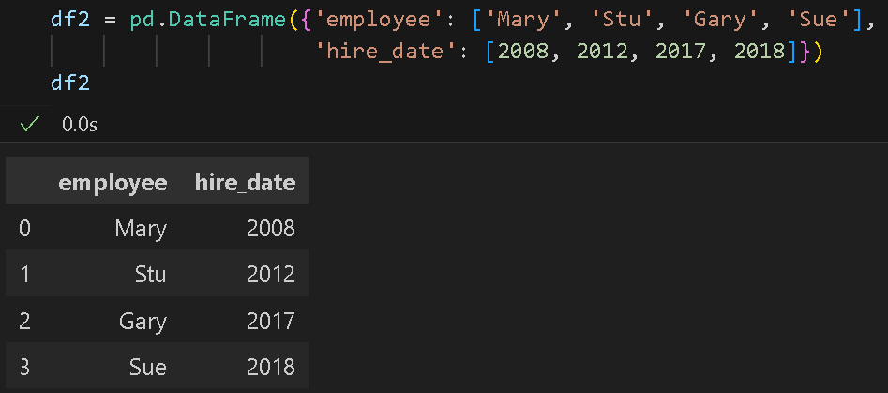

3. We will combine the two DataFrames into one using pandas’ merge function. Type the following code in a new code cell and run it to see the output:
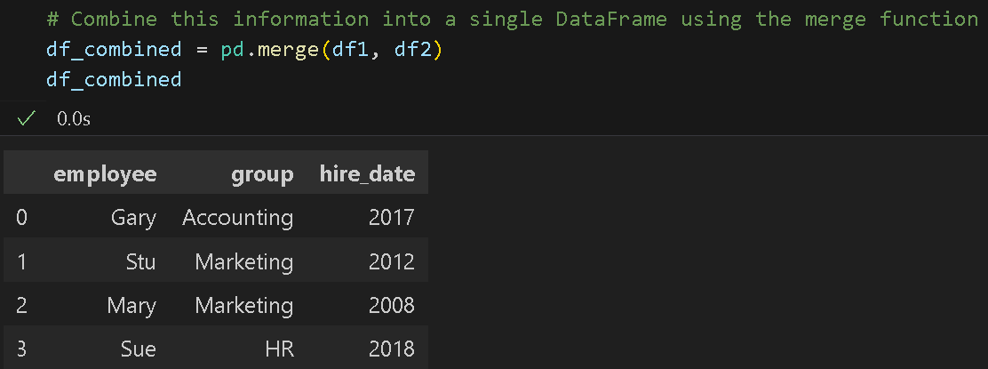

Both df1 and df2 contain the employee column, so the DataFrames were joined on that column.
Note: The indices of df1 and df2 were ignored by the merge method. This is generally the case with merges unless you conduct them by index.

many-to-one Join
In a many-to-one join, many rows from one table may be joined to a single row from another table. This happens when a key column has duplicate entries in another table. The DataFrame
resulting from such a join will preserve the duplicate entries.

4. First, we will declare another DataFrame then join it to our previously combined DataFrames. Type the following code in new code cell and run them to see the output:
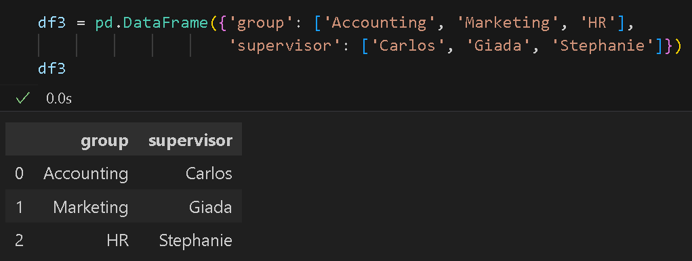

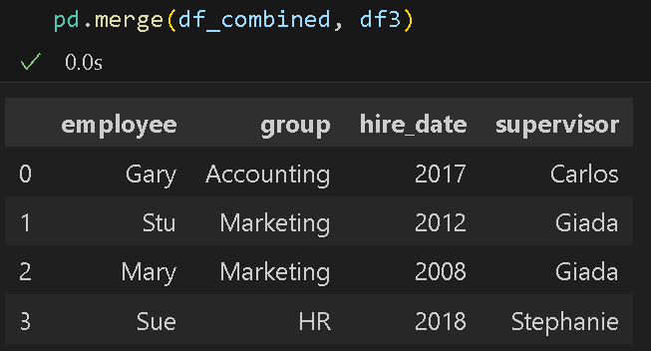

Pandas joined columns using overlapping column names as the key, but it could be confusing which columns were joined if we had many columns meeting the condition. For this reason, it is good practice to clearly specify which key to join on.

- We can set the ‘on’ parameter to specify what columns to join on. Type the following code in a new code cell and run it to see the output:
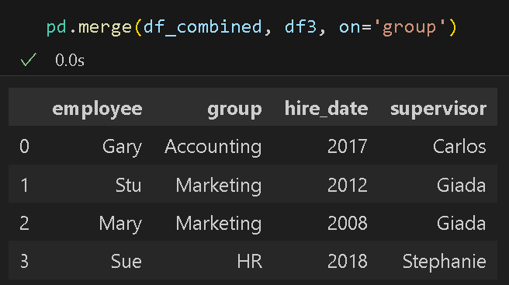

many-to-many Join.
In a many-to-many join, multiple rows from one table may be joined with multiple rows from
Another table.

- First, let us create a new DataFrame containing duplicate values. Type the following code in a new code cell and run it to see the output:
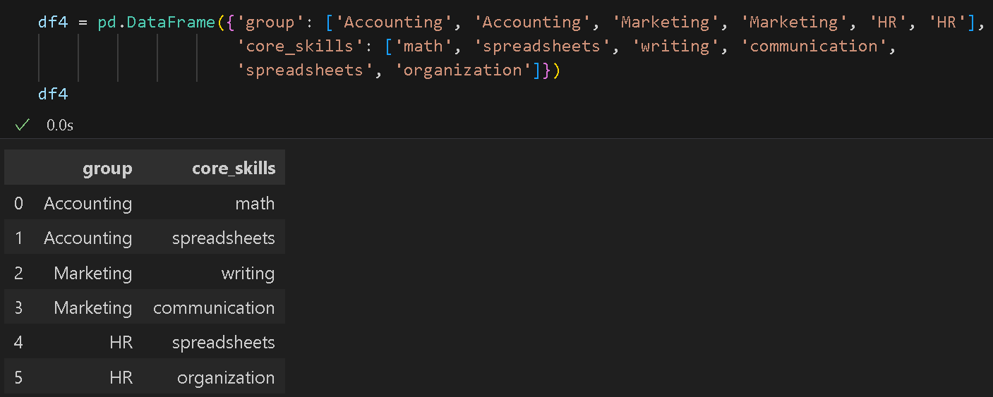

- Now we can join our new DataFrame with the first DataFrame on the group column. We will print df1 again to easily see what is being joined. Type the following code in new code cell and run it to see the output:
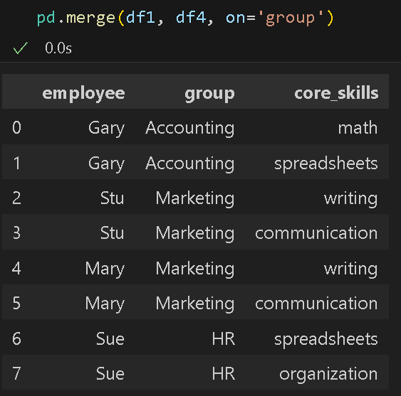

In a many-to-many join we have duplicates date. Employee data from df1 was joined based on the group data from df4.

Merge using ‘how’ argument.
The argument specifies how to determine which keys are to be included in the resulting table. If a key does not appear in either the left or right table, values will be N/A.

possible how values: {‘left,’ ‘right,’ ‘outer,’ ‘inner’ (default)}
• left: use only keys from the left frame, like a SQL left outer join; preserve key order.
• right: use only keys from the right frame, like a SQL right outer join; preserve key order.
• outer: use a union of the keys from both frames, like a SQL full outer join; sort keys lexicographically.
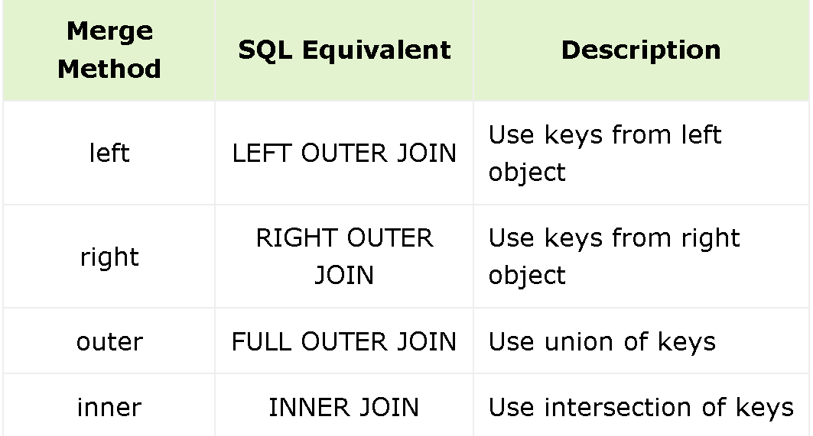
• inner: use an intersection of keys from both frames, like a SQL inner join; preserve the order of the left keys.
- Before we practice with the how argument, let us create a left and right DataFrame. Type the following code in new code cell and run them to see the output:

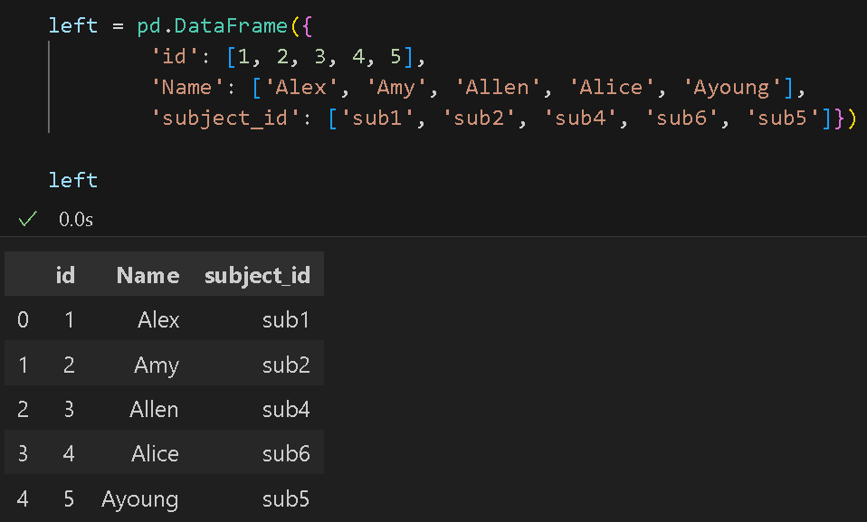
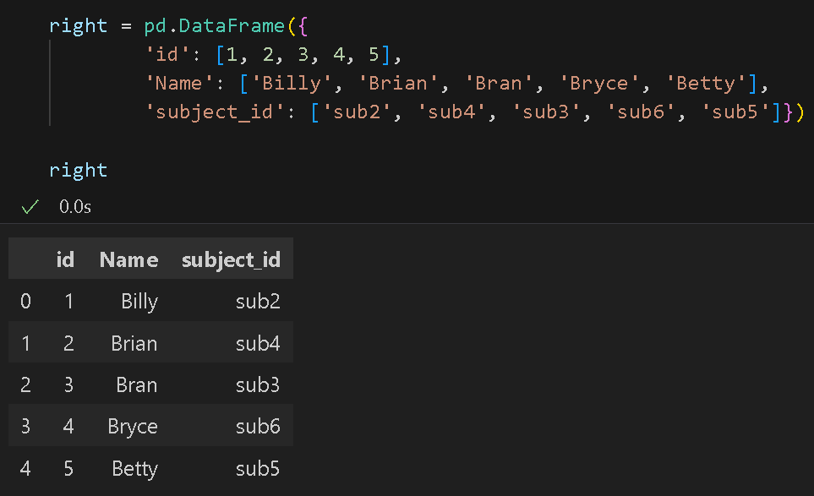
- Now we can try out the merge function with the how parameter. Type the following code in a new code cell and run it to see the output:
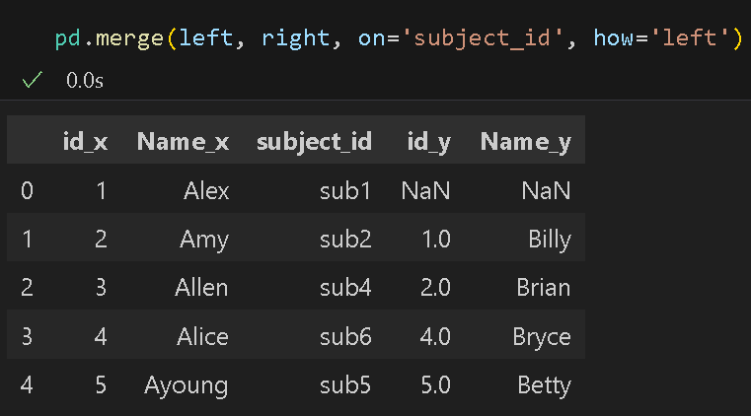
Notice that we joined the two tables on subject_id as the key and only keys from the left table were used. Also, the order did not change when merged.

- Let us try another example using the how parameter, this time using inner as the value. This will use the intersection of keys from both tables. Type the following code in a new code cell and run it to see the output:
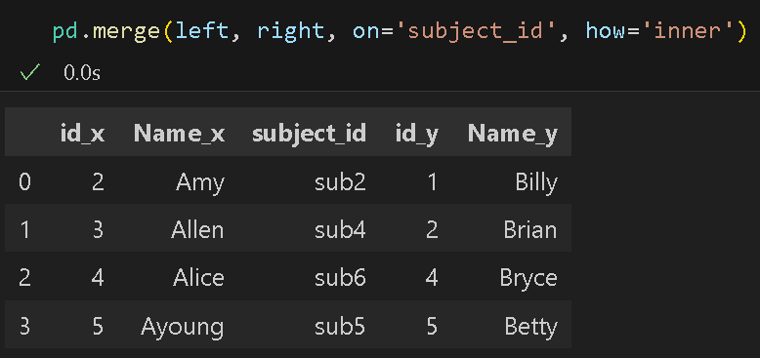
This only selected the values that both tables contain and preserved the order of the left keys.
Sometimes two tables have data that can be joined, but the column names are different. In this
example, we have one table with a column labeled ‘name’ and another table with a column labeled ‘employee.’ In this case, we can use left_on and right_on to specify which column names to join.

- First, we will create a new DataFrame. Type the following code in a new code cell and run it to see the output:
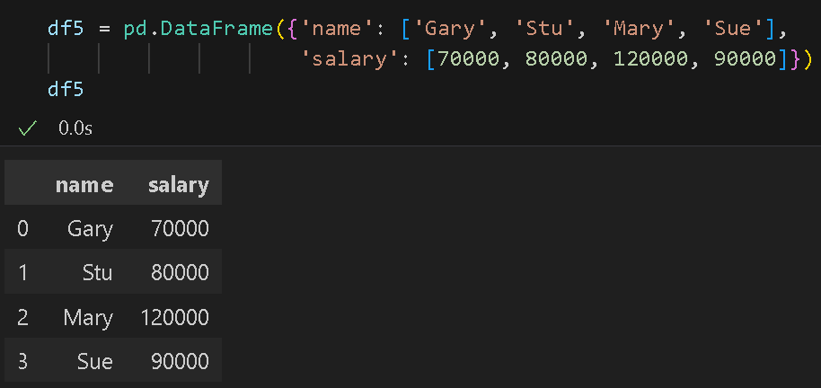

- Now we can specify the left and right table columns to join on. Type the following code in a new code cell and run it to see the output:
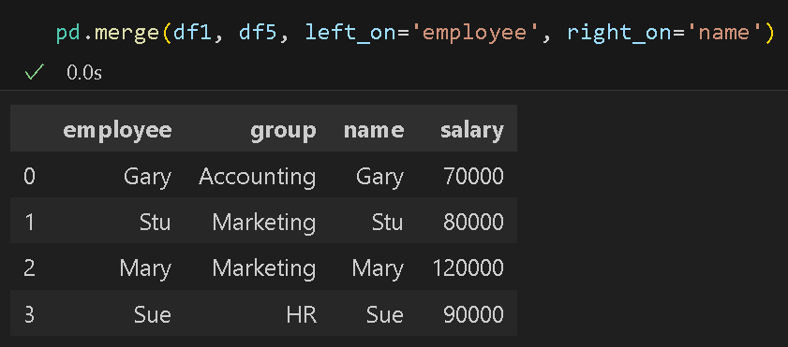

Concatenation
Pandas has a function called pd.concat() that can be used for simple concatenation of Series or
DataFrame objects. The concat function does all the heavy lifting of performing concatenation operations along an axis.

- Let us create two Series and concatenate them together. Type the following code in new code cell and run them to see the output:
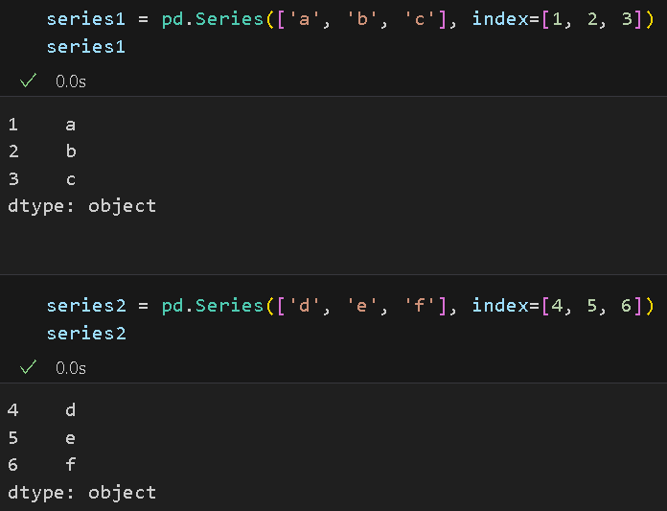
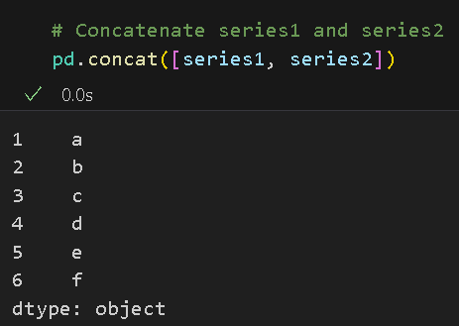

- We can also concatenate DataFrames. Type the following code in new code cell and run them to see the output:
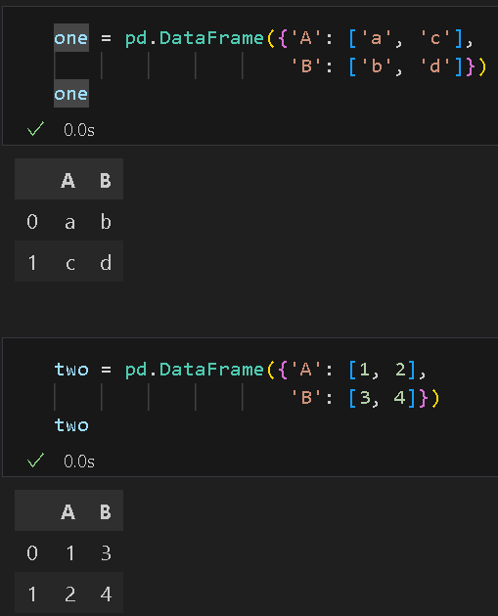
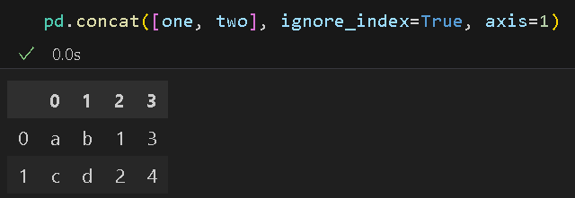
If you want to concatenate column wise, simply remove or change the value of axis to 0. The
keyword ignore_index is used to tell the function not to preserve the index from each DataFrame.

- We can also concatenate DataFrames with different sets of column names. First, we will
create two new DataFrames. Type the following code in new code cell and run them to see the output:
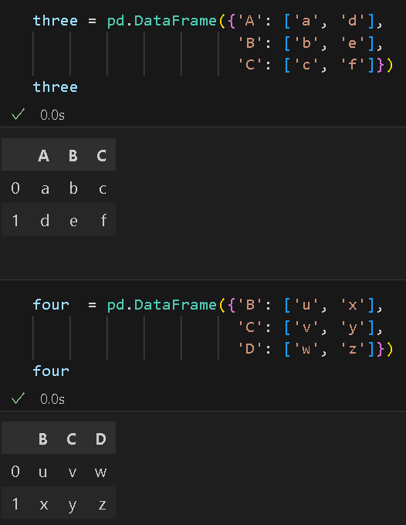
16. Our first option is to use the concat function without any keywords. Type the following code in a new code cell and run it to see the output:
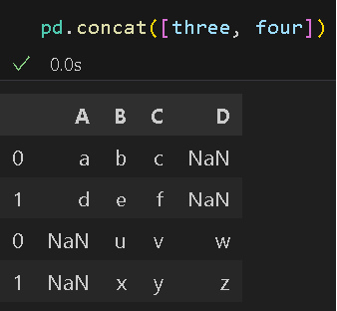
17. We can also apply the inner join to concatenation. Type the following code in a new code cell and run it to see the output:
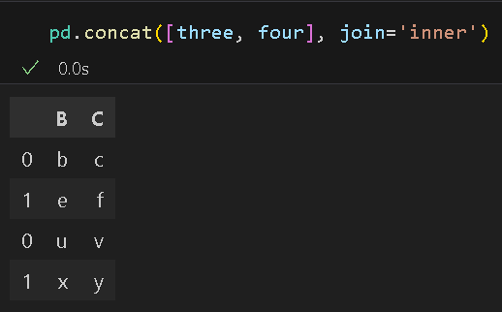

Notice the difference here – when concatenating with inner join, only the two columns in
Both tables have been selected.

Data Transformation
Data transformation is the process of changing the format, structure, or values of data so that the result may be more efficient and easier to understand. This section involves converting data from one structure to another, so you can integrate it with different applications.

1. pivot: Transforming Long Format Data to Wide Format
Concept:
- Pivoting is the process of restructuring data from a long format (where each row represents an observation) to a wide format (where each unique observation is spread across multiple columns).
- This operation essentially "spreads" a column values into separate columns, based on unique entries in another column.

18. Let us transform a dataframe from long to wide format with pivot. Type the following code in a new code cell and run it to see the output:
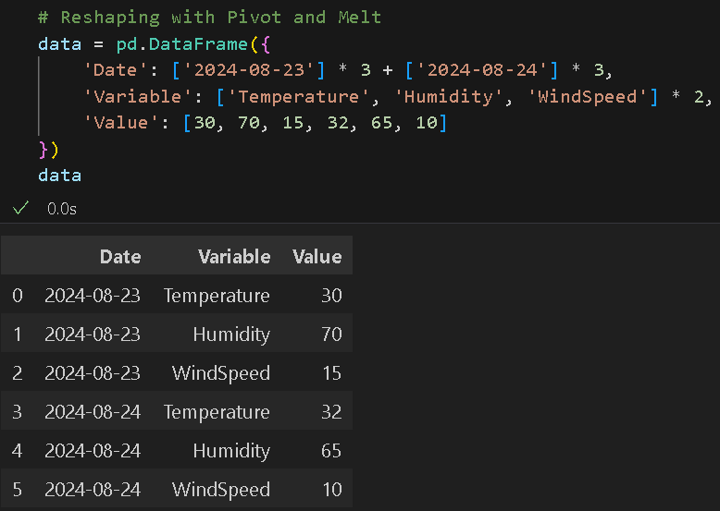
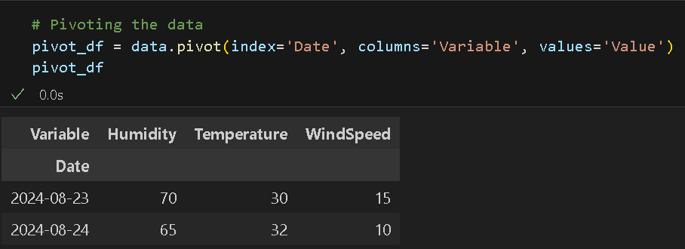
Now, each variable (Humidity, Temperature, WindSpeed) has its own column, and the corresponding values are placed accordingly.

2. Melt: Reversing Pivot to Transform Wide Data Back to Long Format
Concept:
- Melting is the opposite of pivoting. It reshapes data from a wide format back to a long format. In a long format, data is "stacked" into fewer columns, with one column typically representing the variable names and another column representing the values.
- This is useful when you want to revert to the original format or prepare data for certain analyses or visualizations that require long-format data.

19. Let us transform the dataframe back from wide to long format with melt. Type the following code in a new code cell and run it to see the output:
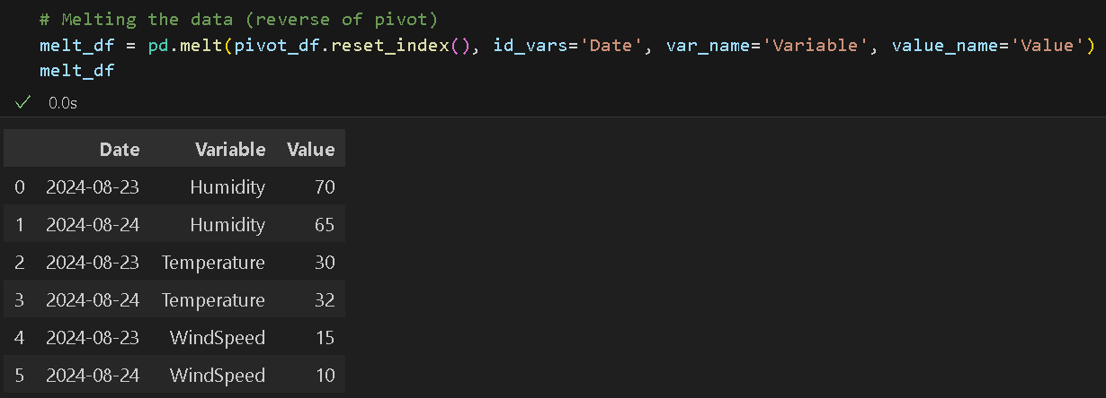
The data is now back to its original long format. The Variable column contains the variable names, and the Value column contains their corresponding values, just like before we applied the pivot operation.

3. Stacking: Compressing or Pivot Longer
Concept:
- Stacking is the process of moving the column labels into the row index, effectively "compressing" or "pivoting longer" the DataFrame.
- The stack operation moves the innermost column level (in this case, the variable columns) to the row index, effectively "stacking" the columns vertically into a single column. This creates a long-format DataFrame.

20. Type the following code to create a new dataframe that we can work on and run to see what it looks like:
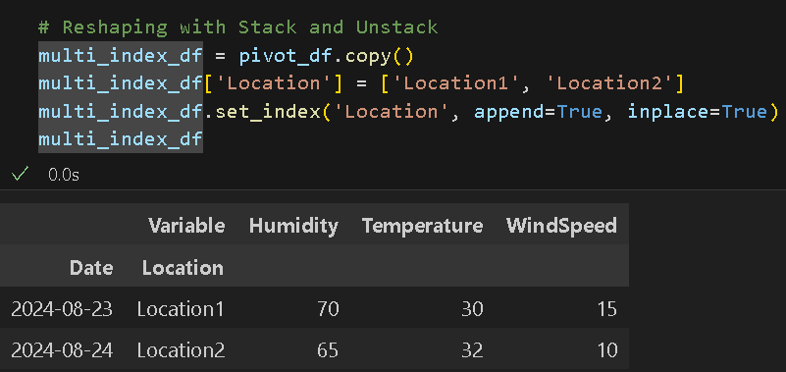

22. Let us create a long-format DataFrame with stack(). Type the following code in a new code cell and run it to see the output:
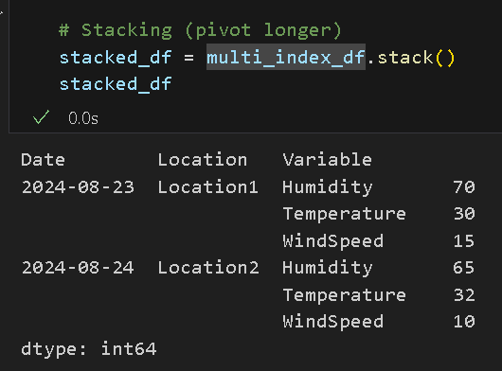
Now, the Variable column headers (Humidity, Temperature, WindSpeed) have been stacked as part of the row index, and the DataFrame is converted into a Series with a hierarchical index. Each combination of Date, Location, and Variable now represents a unique key, and the corresponding value is associated with that key.

4. Unstacking: Expanding or Pivot Wider
Concept:
- Unstacking is the reverse operation, where row index levels are moved to become column labels, effectively "expanding" or "pivoting wider" the DataFrame.
- The unstack operation does the reverse of stack. It moves the innermost row index level (in this case, Variable) to become the columns, effectively "unstacking" the data into a wide format.

22. Let us see what unstack () does to the dataframe. Type the following code in a new code cell and run it to see the output:
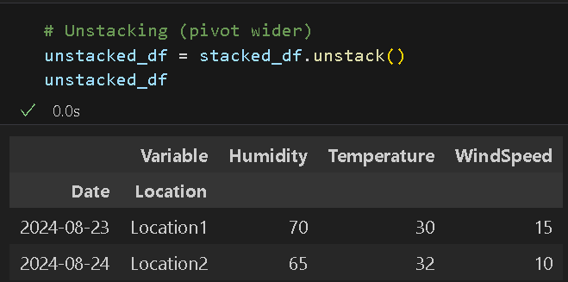
This returns the DataFrame to its previous wide format, where Variable values are the columns, and Date and Location form the hierarchical index.

5. transform(): Broadcasting Transformed Data to DataFrame
Concept:
- This is used when you want to perform some element-wise operation on a group of data, returning an output that has the same shape as the input.
- Unlike agg(), which reduces data, transform() can be used to broadcast the result back to the original DataFrame.

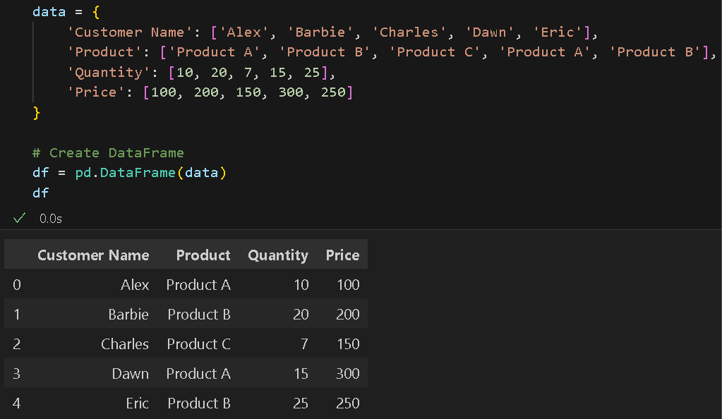
24. With Pandas, we can perform transformations easily. We performed data transformations in previous HOS and PE assignments, this time, we will use the transform function. Type the following code and run the code cells to see the output:

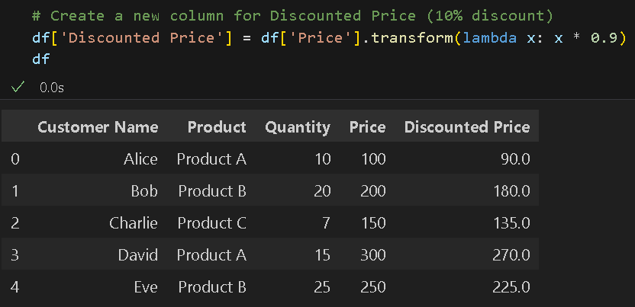
25. Next, we will use the transform() function to create a new column called ‘Discounted Price’ where we apply a 10% discount to the original ‘Price’. Type the following code in a new code cell and run it to see the output:

Notice that we used an anonymous function (lambda) to multiply 0.9 to each value. This way, all non-empty values have been added to successfully. The result of using the transform function is typically a DataFrame of the same length, but it is possible to provide several input functions.

23. This time, we will use the transform function to find the square root and the result of Euler’s number for each number. Type the following code in a new code cell and run it to see the output:

>> Import numpy as np in a new cell
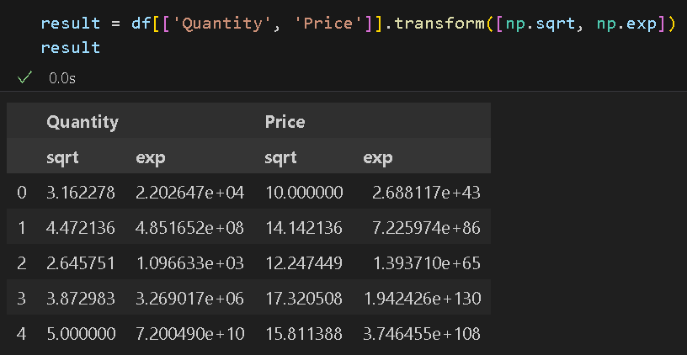
6. Data Discretization:
Concept:
- This is the process of converting continuous data attribute values into a
finite set of intervals with minimal loss of information.
- For example, if you have height data, you may want to discretize it to intervals between 0 and 1 depending on whether the height is above or below particular threshold values.

24. In the same file, we will create a NumPy array with ten random integers between 10 and 200. Type the following code in a new code cell and run it to see the output: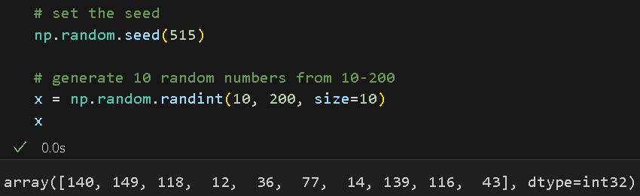

25. NumPy provides some of the functions you can perform discretization with – one is digitize(). This next line of code will discretize where 50 is the threshold to divide the data into two categories: one with values less than 50 and one with values above 50. Type the following code in a new code cell and run it to see the output:
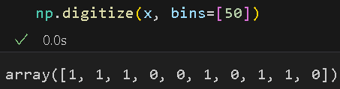
The bins argument is a list, so we can specify multiple binning or discretization conditions if we want/need to. As you can see here, there are four numbers lower than 50 (represented by 0) and the rest are higher than 50 (represented by 1).

26. If we want to have three categories, how many values should we specify in the bins array? To have three categories, we should specify two values. Type the following code in a new code cell and run it to see the output:
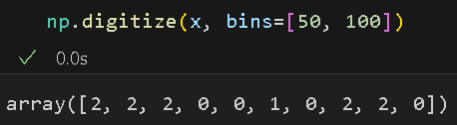
Now we have what we want: three categories (0, 1, and 2). 0 represents values less than 50, 1 represents values between 50 and 100, and 2 represents values more than 100.

27. Next, let us use a function from pandas called cut() to categorize our data into discrete intervals. While it serves a similar purpose to NumPy’s digitize() function, it operates in a different way. Enter the following code in a new code cell and run it to see the output:
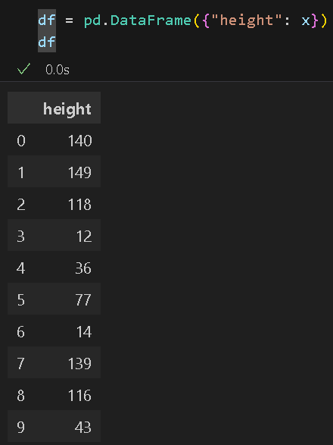
Here we created ten values in the height column with indexes ranging from 0-9.

28. Now we can categorize the height variable into four categories using the Pandas cut() function. Type the following code in a new code cell and run it to see the output:
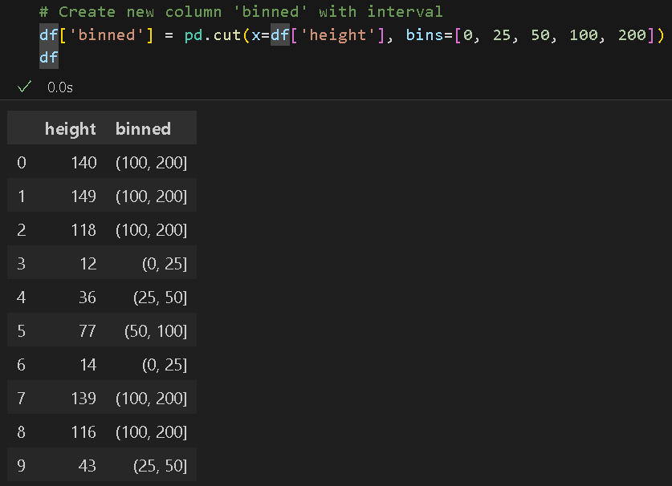
The height values between 0 and 25 are in one category, between 25 and 50 are in the second category, between 50 to 100 are in the third category, and between 100 to 200 are in the
fourth category.

29. We can also label bins. Type the following code in a new code cell and run it to see the
Output
: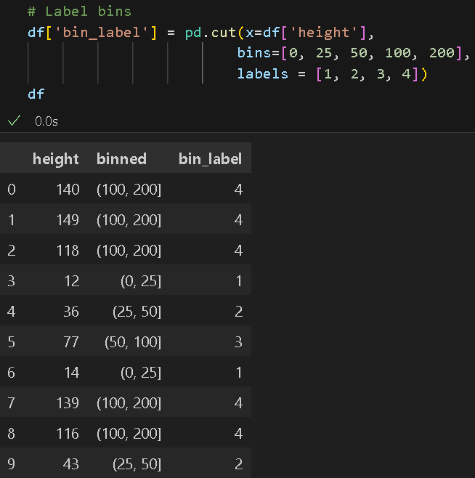
You can also set labels as strings instead of numbers.

30. Pandas has another function called qcut() which discretizes variables into equal-sized buckets. You only need to tell the function the number of quantiles and pandas will figure out how to bin the data. Type the following code in a new code cell and run it to see the output: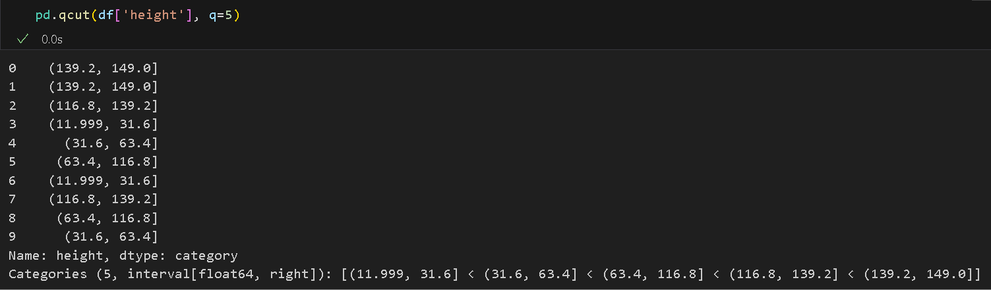
Notice that qcut() discretized the data into equal sized bins, but the intervals are not equal.
The data is binned into five groups with two members each. Unlike what the cut() function does, which has no guarantee about the distribution of items in each bin, the interval is the same for all bins.

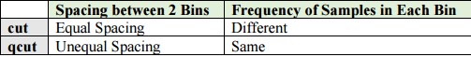

31. Let us look at a familiar example of how to discretize data. Type the following code in a new code cell and run it to see the output:
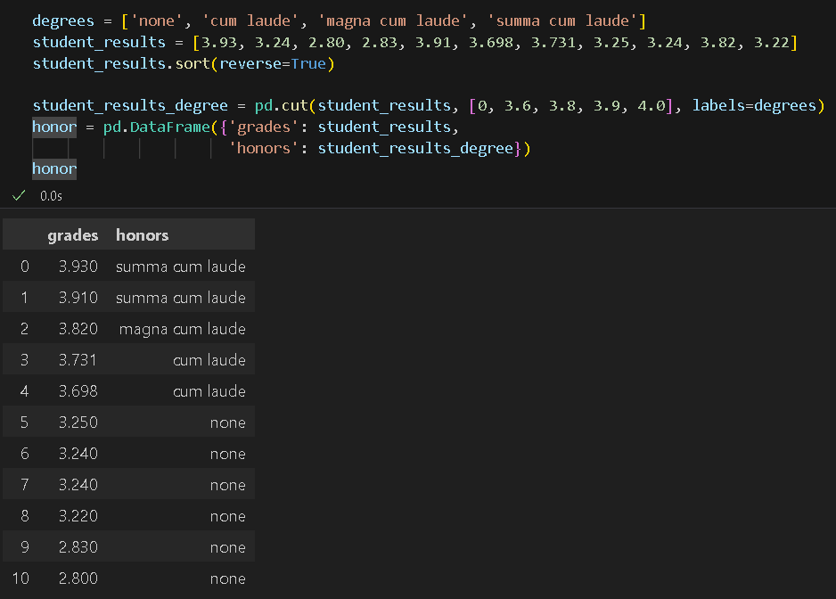
In the third line of code, we sorted the data to make it easier to see what is in each category.
Then, we categorized which grades belong to which category. Finally, we put the data into a
DataFrame.

32. It may be helpful to see a visualization of the data. We can do this with a basic plot provided by pandas as seen below. We will plot a bar plot based on the number of students in each group. Type the following code in a new code cell and run it to see the output: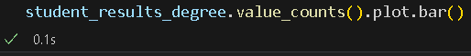
Note: In case you get the following error: “ModuleNotFoundError: No module named matplotlib,” this is because you have not installed the matplotlib library in your system. To do that, open a new terminal, then in the terminal, type the following command to install the matplotlib library: pip install matplotlib

Rerun your code cell.
If you want to see what value_count() does, remove plot.bar() from your code.
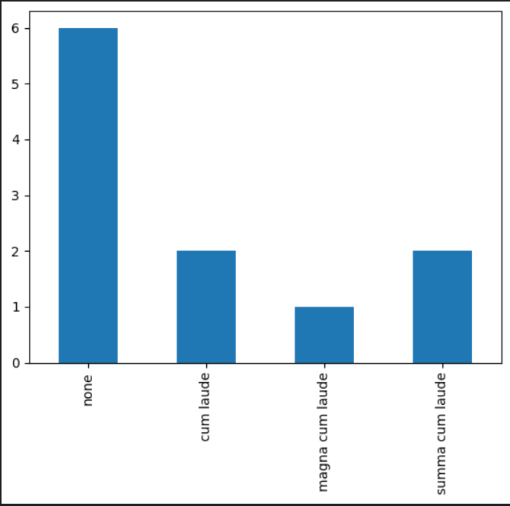
*** This is the end of the HOS7A-1 exercise. Please proceed on working on HOS7A-2 and answer HOS07B in Brightspace after pushing your work to GitHub. ***

Push your work to GitHub.
Follow the instructions on the CityU STC TA Center Github.io Submit your work page

You may also follow the instructions below:
1. Open the cmd terminal for Windows users,
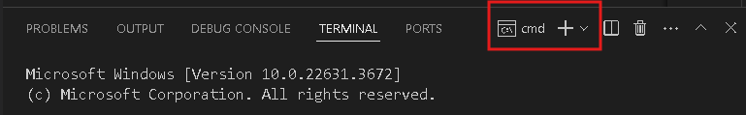

2. After selecting the + button, make sure the terminal is cmd if you have not closed the Python terminal.

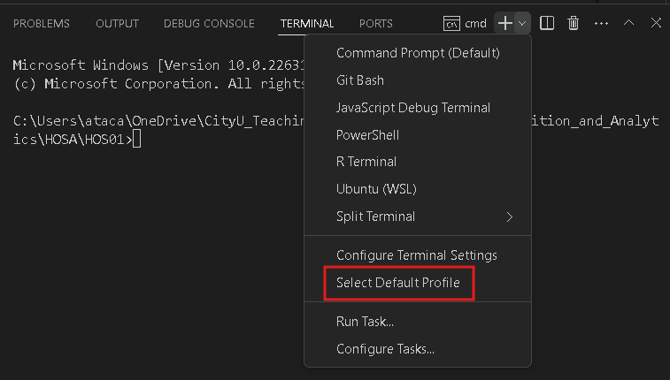
If the terminal is not cmd, then you need to add it by opening the drop-down box, choose the Select Default Profile.

Look for and then select Command Prompt
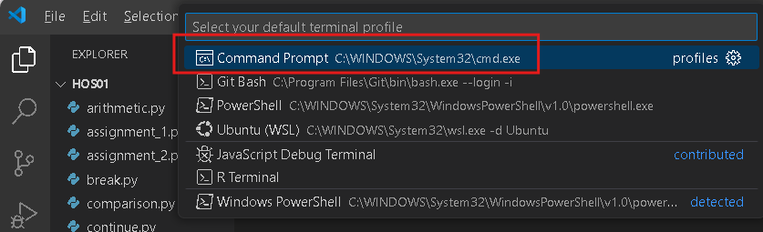

Click the + button. The command prompt will open.

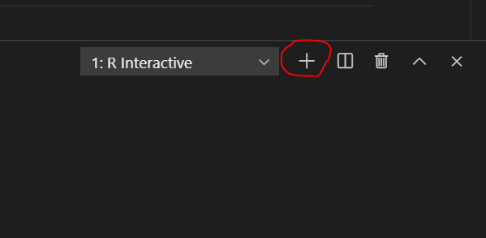



3. Make sure you are in the correct directory/repository: Desktop/DS522/hos07a-courseName-yourUserName

Run the following commands to push your work to the GitHub repository:
Open the terminal from the VSCode by hitting the control + ~ key and type the following command:
>>> git add .
>>> git commit -m “Submission for HOS07A-1.”
>>> git push

